Name: Bilal Abid Abbasi
ID:45961
OOP LAB TASK 2:

1) Hospital Management System
#include <iostream>
using namespace std;
struct Patient
{
string name;
int age;
string disease;
string admissionDate;
};
int main()
{
int n;
cout<<"Enter number of patients: ";
cin>>n;
Patient p[100];
for(int i=0; i<n; i++)
{
cout<<"\nPatient "<<i+1<<endl;
cout<<"Name: ";
cin>>p[i].name;
cout<<"Age: ";
cin>>p[i].age;
cout<<"Disease: ";
cin>>p[i].disease;
cout<<"Admission Date: ";
cin>>p[i].admissionDate;
}
cout<<"\nPatient Records\n";
for(int i=0; i<n; i++)
{
cout<<"\nName: "<<p[i].name<<endl;
cout<<"Age: "<<p[i].age<<endl;
cout<<"Disease: "<<p[i].disease<<endl;
cout<<"Admission Date: "<<p[i].admissionDate<<endl;
}
return 0;
}
Output:

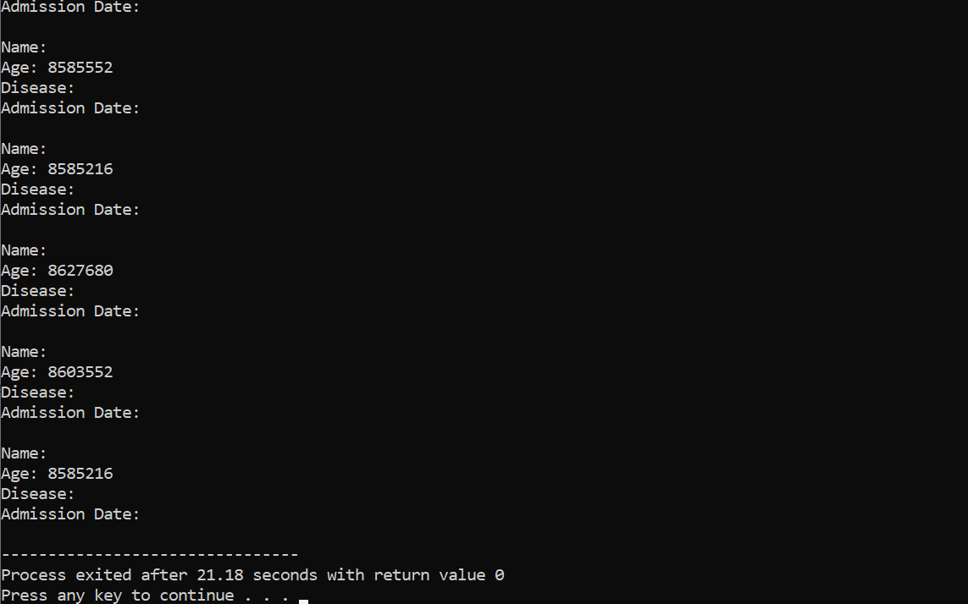

2) Vehicle Registration System
#include <iostream>
using namespace std;
struct Vehicle
{
string regNo;
string ownerName;
string model;
int year;
};
int main()
{
int n;
cout<<"Enter number of vehicles: ";
cin>>n;
Vehicle v[100];
for(int i=0; i<n; i++)
{
cout<<"\nVehicle "<<i+1<<endl;
cout<<"Registration Number: ";
cin>>v[i].regNo;
cout<<"Owner Name: ";
cin>>v[i].ownerName;
cout<<"Model: ";
cin>>v[i].model;
cout<<"Manufacturing Year: ";
cin>>v[i].year;
}
cout<<"\nVehicle Records\n";
for(int i=0; i<n; i++)
{
cout<<"\nRegistration Number: "<<v[i].regNo<<endl;
cout<<"Owner Name: "<<v[i].ownerName<<endl;
cout<<"Model: "<<v[i].model<<endl;
cout<<"Year: "<<v[i].year<<endl;
}
return 0;
}

Output:

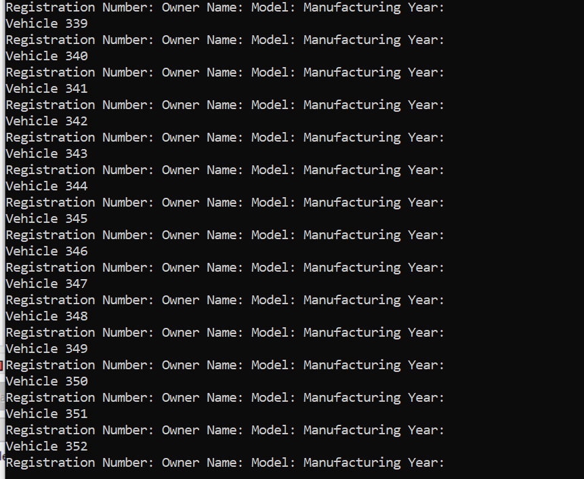

3) Employee Attendance System
#include <iostream>
using namespace std;
struct Employee
{
string name;
int id;
string department;
char status;
};
int main()
{
int n;
cout<<"Enter number of employees: ";
cin>>n;
Employee e[100];
for(int i=0; i<n; i++)
{
cout<<"\nEmployee "<<i+1<<endl;
cout<<"Name: ";
cin>>e[i].name;
cout<<"ID: ";
cin>>e[i].id;
cout<<"Department: ";
cin>>e[i].department;
cout<<"Attendance (P/A): ";
cin>>e[i].status;
}
cout<<"\nAttendance Record\n";
for(int i=0; i<n; i++)
{
cout<<"\nName: "<<e[i].name<<endl;
cout<<"ID: "<<e[i].id<<endl;
cout<<"Department: "<<e[i].department<<endl;
if(e[i].status=='P' || e[i].status=='p')
cout<<"Status: Present"<<endl;
else
cout<<"Status: Absent"<<endl;
}
return 0;
}

Output:
